Appendix: Chapter 7

Prevention of well clogging by spatial and financial attractive measures during aquifer storage of tile drainage water

Emiel Kruisdijk1,2*, Julian F. Ros1*, Devanita Ghosh1*,* Maren Brehme1, Pieter J. Stuyfzand1,3, Boris M. van Breukelen1

1Delft University of Technology, Faculty of Civil Engineering and Geosciences, Department of Water Management, Stevinweg 1, 2628 CN Delft, the Netherlands

2Acacia Water B.V., Van Hogendorpplein 4, 2805 BM Gouda, the Netherlands

3Stuyfzand Hydroconsult+, 2042 BL Zandvoort, the Netherlands

*These authors contributed equally to this work

Corresponding author: [e.kruisdijk@tudelft.nl](mailto:e.kruisdijk@tudelft.nl)

# S1. More information on the ASTR system

Figure S1: Schematic representation of the ASTR system.

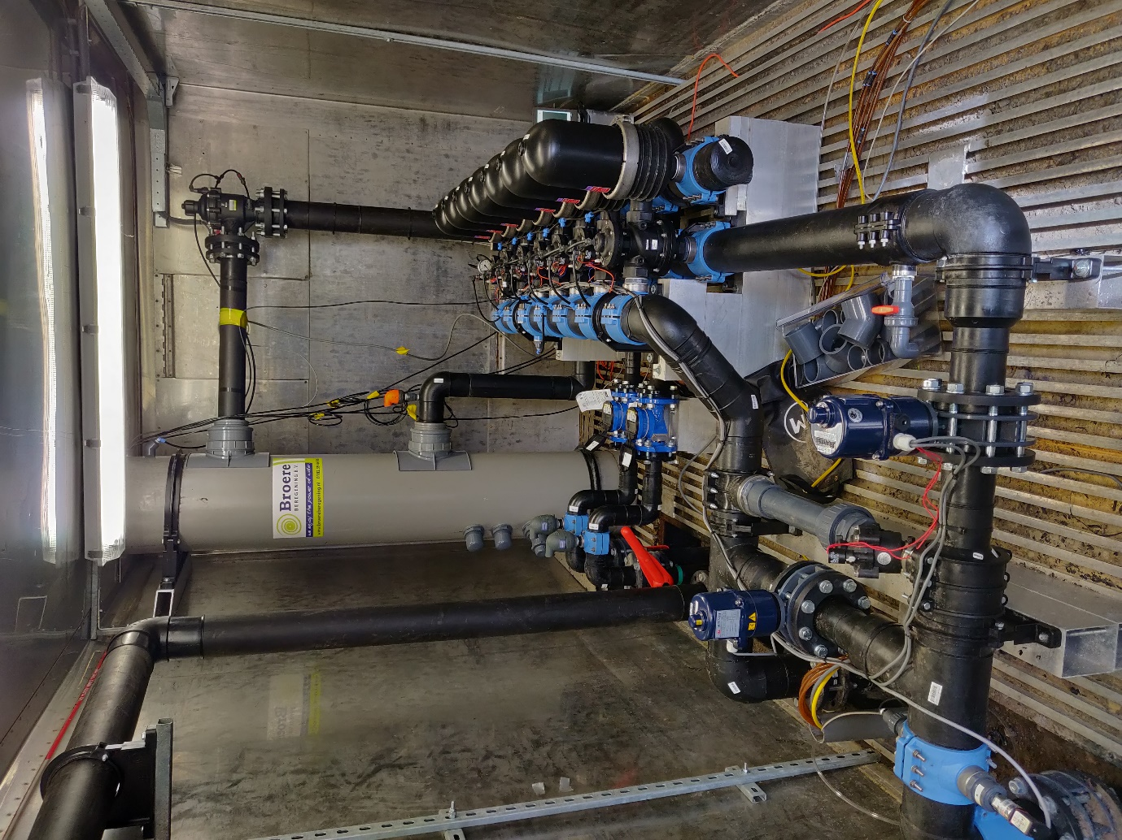

Figure S2: Impression of the disc-filters and the standpipe in the container.

# S2. Relation between recharge flow (m3/h) and head rise at MW-3

Table S1: Relation between the observed head rise at MW-3 and the injected recharge flow.

# S3. Tile drainage water composition

Table S2: Composition of mean injected TDW estimated based on 66 samples, from which the largest part (n=43) are taken at the first 6 days of ASTR operation, the rest is taken as part of regular monitoring (n=23). The TDW samples are therefore not equally spread over time, and can have a bias to the first 6 days of ASTR operation.

|  |  |  |
| --- | --- | --- |
|  |  | **Mean. TDW** |
| **Sample date** | **-** | 25-02-2019:  18-03-2021 |
| **Depth filter** | **m-b.s.l** | **-** |
|  |  |  |
| **temp** | **°C** | 10.1±2.6 |
| **pH** | **-** | 7.21±0.33 |
| **EC** | **μS/cm** | 1293±397 |
| **Turbidity** | **NTU** | 9.66±33.7 |
| **DOC** | **mg/L** | 24.7±4.2 |
| **O2** | **mg/L** | 6.4±1.9 |
| ***Water composition*** | | |
| **Cl** | **mg/L** | 160±61 |
| **Br** | **mg/L** | 0.4±0.3 |
| **O2** | **mg/L** | 4.3±0.7 |
| **NO3** | **mg/L** | 14.1±11.3 |
| **PO4** | **mg/L** | 5.21±0.80 |
| **NH4** | **mg/L** | 0.13±0.11 |
| **SO4** | **mg/L** | 193±55 |
| **Alkalinity**  **(as HCO3)** | **mg/L** | 367±13 |
| **Na** | **mg/L** | 90.4±37.8 |
| **K** | **mg/L** | 52.3±14.0 |
| **Ca** | **mg/L** | 172±42.9 |
| **Mg** | **mg/L** | 31.1±7.4 |
| **Fe** | **mg/L** | 0.14±0.19 |
| **Mn** | **mg/L** | 0.43±0.14 |
| **As** | **μg/L** | 9.3±2.3 |
| **Saturation indices** | | |
| **Hydroxyapatite** | **-** | 3.0 |
| **Ferrihydrite** | **-** | 1.3 |
| **Fe-hydroxyphosphate** | **-** | 15 |
| **Calcite** | **-** | 0.3 |

# S4. Reduction in clogging material after acidification

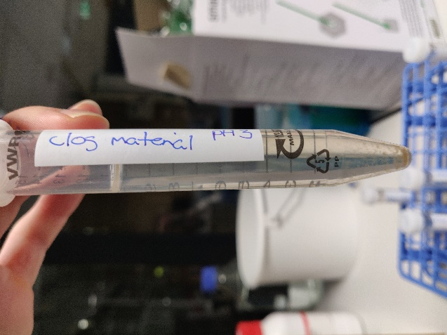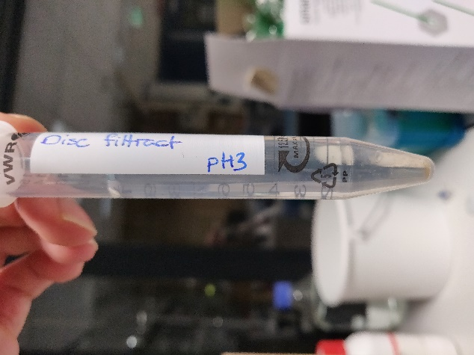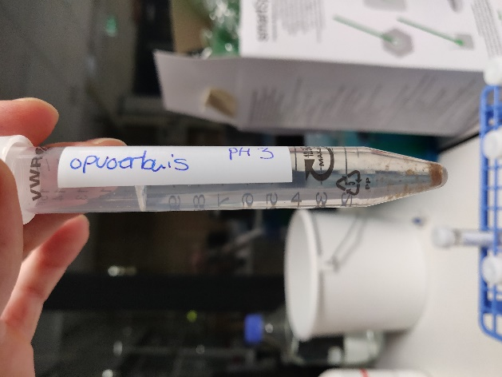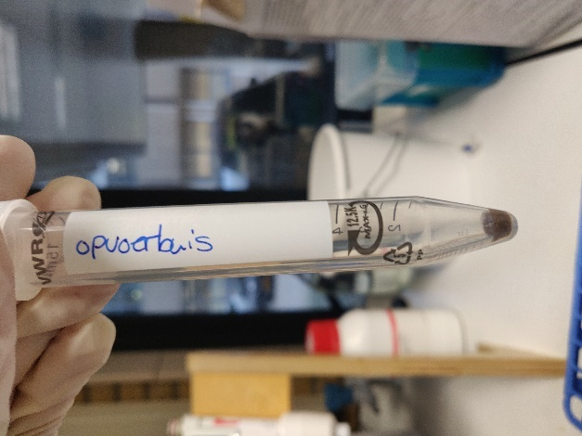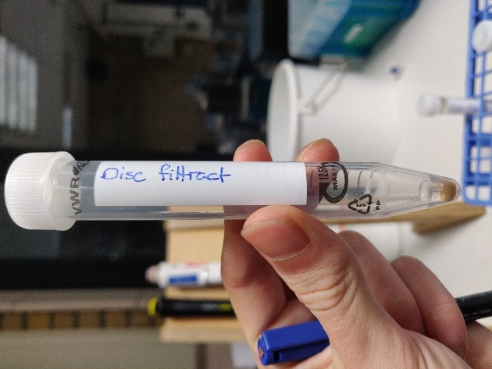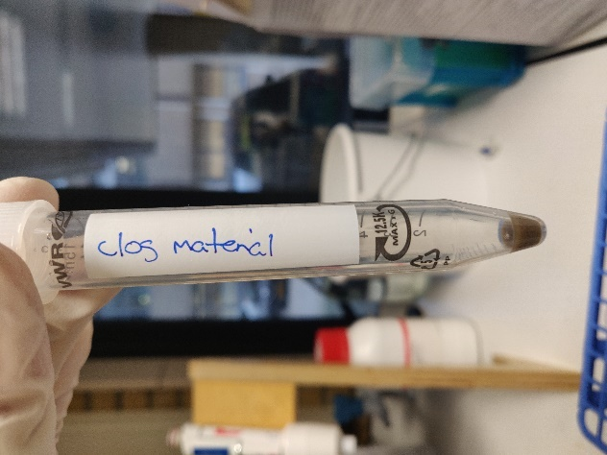

*Figure S3: Acidification test with 69% HNO3 (1:100) to investigate the presence of metal-oxides in removed suspended material from the well rehabilitation on 25 November 2020 (left column, top before acidification, bottom after acidification). Middle column corresponds to the material removed from the disc filters and the right column corresponds to material removed from the standpipe interior.*

# S5. Visual observation of stagnant water in standpipe

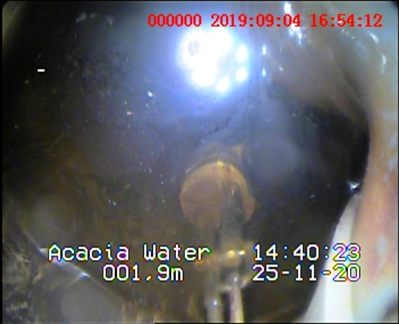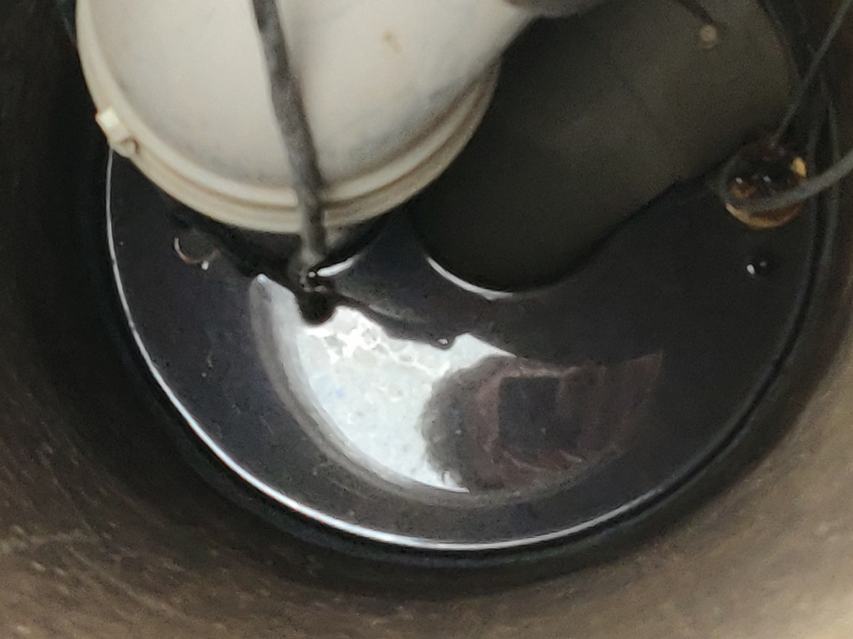

Figure S4: Metallic sheen on stagnant water within the standpipe taken November 25th, 2020 after a 41-day standstill.

Figure S5: Metallic sheen on stagnant water within the standpipe taken November 25th, 2020 after a 41-day standstill.

# S6. Visual observations of adhered mat within standpipe

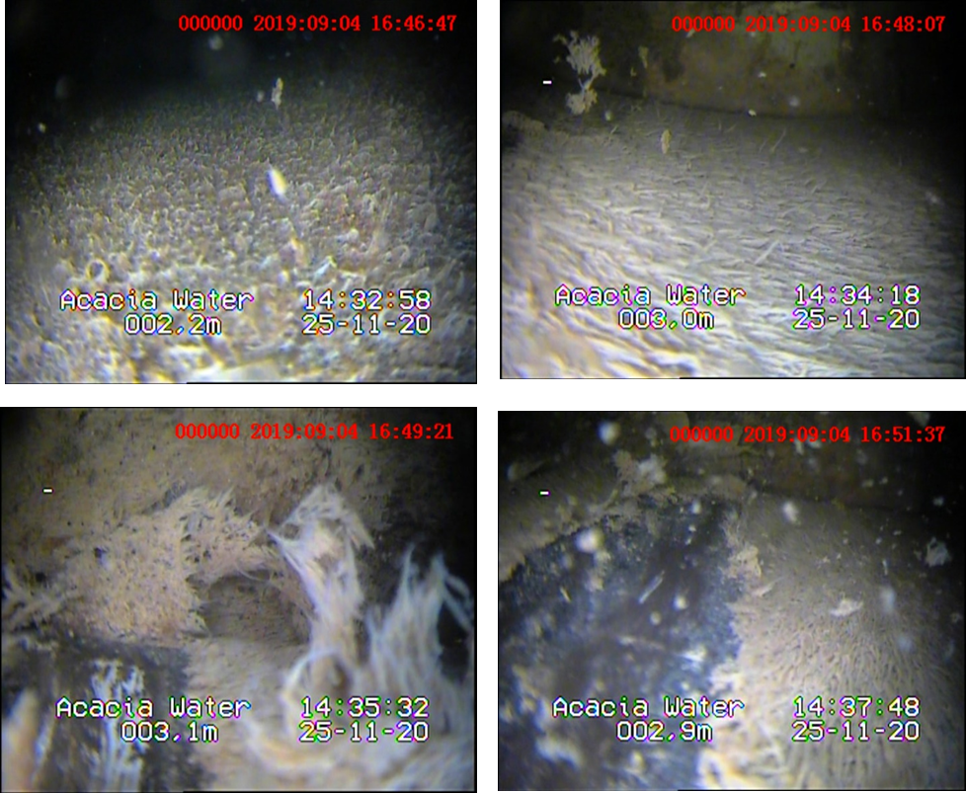

Figure S6: Several shots of the conditions within the standpipe taken November 25th, 2020 after a 41-day standstill. A thick mat of microbial deposits covered the pipe interior and seemed to thicken with depth. The image below shows the standpipe material colour.

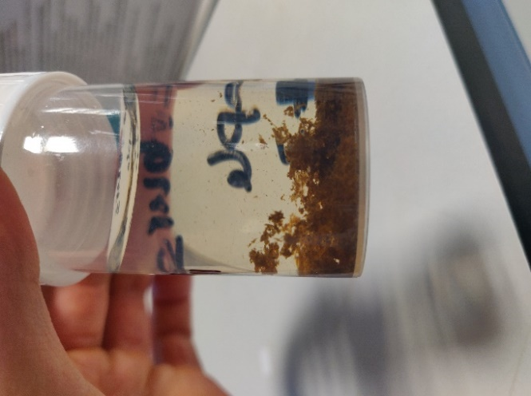

Figure S7: Color of the standpipe material above ground

# S7. Visual observations of inner wall at tile drainage outlet

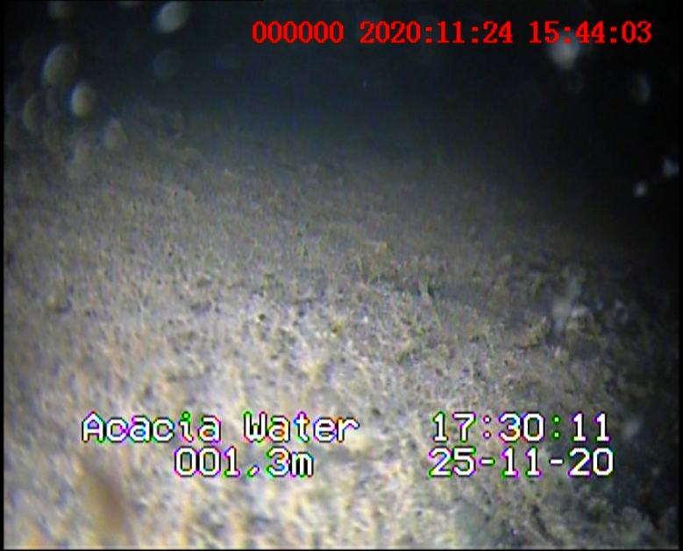

Figure S8: Camera shot of the conditions within the main tile outlet discharging tile drainage water to the drain reservoir. A mat of microbial deposits similar to that in the standpipe (fig. 5.3) is seen.

# S8. Obtained data for injection well 2 (INJ-2)

Figure S9: Data obtained during injection period 1 (green; 23 days of injection), period 2 (red; 25 days of injection), and period 3 (blue; 66 days of injection): Precipitation (mm/d), phreatic water level in the field (cm-b.s.l.), injectivity index (m3/hr/bar) of INJ-1, water level rise (cmH2O) due to clogging in INJ-2 (measured in MW-2) and at distance (MW-3) at 7m from INJ-2, and turbidity level (NTU) of injected water after the disc-filters measured in the standpipe. No data on phreatic surface level could be gathered between 29 November to 11 December 2019 (1st injection period).

